Vertebrate Biology – Evolution Study Guide

Metabolism

Define:

What are the 2 types

Pros and Con to each Type

3 Characters of Each type and why they would need them
- example: large chest cavity in endotherms because they need it to fit complex lung and hearts since endothermy requires high levels of cellular respiration and therefore has a high O₂ requirements.

Cladistics
Ancestral vs Derived traits
Ancestral | Derived

Be able to build a cladogram and interpret the information that it represents

What evidence is used to construct/inform a cladogram (3)
1.
2.
3.

Skeleton Lab and Track that Change Activity
What does complexity of a structure represent about its evolution?

What is the meaning of Occam’s Razor in terms of evolution?
Definition: hypotheses that which makes the fewest assumptions and thereby offers the simplest explanation of the effect.

Describe the trend in heart and lung development and reproduction method and what that indicates about their mobility and habitat use.
Ex: Lung:
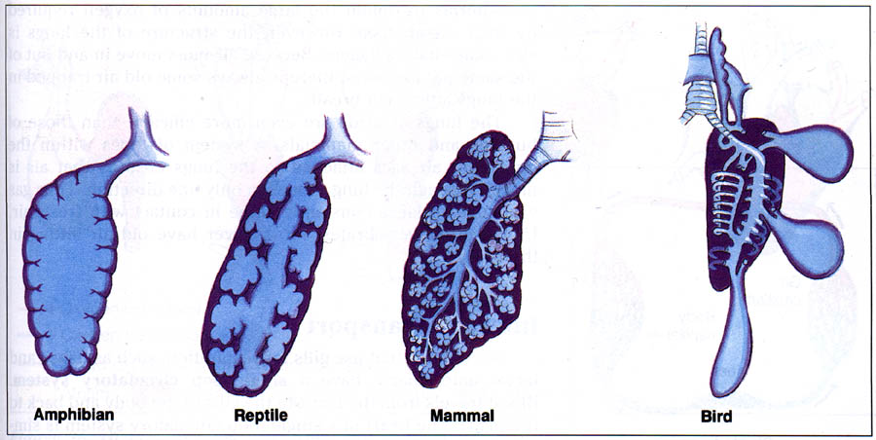
Increasing complexity (Shown by more surface area for gas exchange)

- Need more 0₂
  - for more active life style
  - Life on land

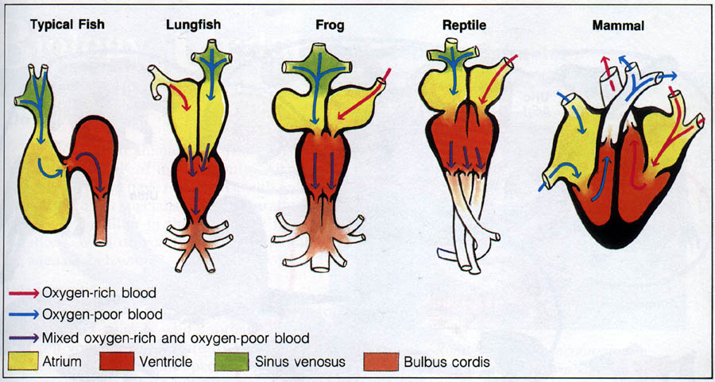

Can you explain the evolutionary trend of habitat use? And be able to support it with evidence
Water ⇒ land ⇒ and occasionally back to water

