Biology Course Description
Zannie Dallara  ZDallara@themarinschool.org  http://zanniedallara.weebly.com | 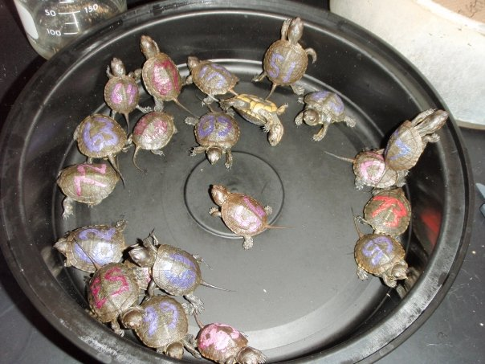
This class is a laboratory based science class that focuses on four major units to teach skills and concepts in biology. You will apply scientific processes to solve problems through the use of data analysis and drawing conclusions. You should be able to make connections between scientific disciplines while forming knowledge and opinions about topics and issues we discuss this year.

Class Requirements: Arrive on time and prepared for class.

"Prepared" means that you have:

* notes + handouts (in a folder/binder or laptop)
(divide into four sections titled "notes", "assignments", "labs", and "tests")
* paper
* something to write with

Since some of the class will revolve around the discussion of certain controversial biosocial issues, certain ground rules have been established:

- Respect –
For each other, the teacher, and any speakers.
One person talks at a time. Please raise your hand.
2. No Put Downs -
No preaching of your values, and no put downs of other people's values.
All points of view are worthy of being discussed.
3. Right to pass
4. Confidentiality
5. Ask questions! - There is no such thing as a "dumb question".

Grading: Your semester grade is figured like this:
Tests = 30%
Labs = 15%
Projects = 15%
Notebook – 5%
Written Assignments = 15%
Participation – 10%
Final exam = 10%

Syllabus (not necessarily in this order)

- Introduction
- Characteristics of Living Things
- Scientific Method/Experimental Design
- Biochemistry
Energy Flow in the Life of a Cell
Cell Membrane Structure and Function
Cell Structure and Function
Photosynthesis
Respiration
- DNA

Gene Expression and Regulation
Cellular Reproduction
Genetics
Biotechnology
- Evolution
- History of Life on Earth
- Biodiversity
- Human Body
- On-going project = Sand crab monitoring

Class Presence: Basic classroom discipline will operate on the "Three strikes and you're out" principle - if you have to be addressed for behavioral issues more than twice during a class, you will be asked to leave. Each day you will receive a grade on a four-point scale:
4 pts. = Prepared, positive participation
3 pts. = Prepared, no participation
2 pts. = Not prepared, positive participation
1 pts. = Not prepared, no participation
Points will be subtracted due to negative behavior and unexcused tardies.
Remember classroom etiquette.

Assignments: Your assignments should be completed the night before they are due. Assignments are graded on your initial effort on a 10-point scale:
Content = 4 points
Completely done = 4 points
Neatness + formatting= 2 points.

Special Projects and Incentives: Students will receive teacher support and mentoring in the research, experimentation and presentation of a Science Fair Project, due at the end of first semester. A student whose course grade is at least 80% and whose project earns a 1st place in the Marin County Science Fair will receive an automatic “A” in the second semester. Extra Credit may be offered to students who have completed all their regular work but may not exceed 3% of the total points possible in any given semester. If you can maintain an A- average in the class (after two tests), the completion requirement for some assignments may become optional. You will still be responsible for the material. Labs and papers will still be due on time or are considered incomplete and will lose points for being late.

