Physiology Course Description
Zannie Dallara  ZDallara@themarinschool.org  http://zanniedallara.weebly.com  Wing 1 – Classroom 4  Phone Ext 130 | 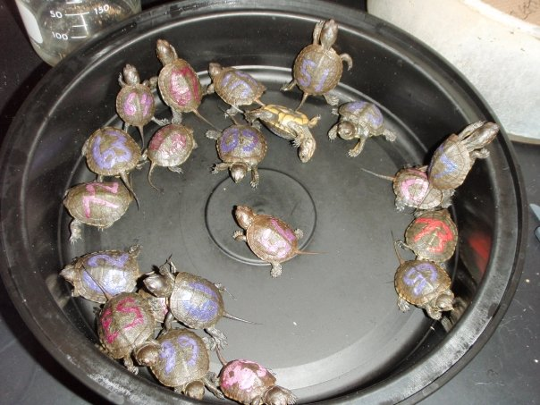
This course is designed to teach students about human anatomy and physiology while understanding the way body parts work individually as well as working together. This will require higher-level knowledge, comprehension and application. The focus is on the study of the systems of the body with an emphasis on the causes and effects of diseases within the systems. Students will gain a better appreciation for their bodies, how they function and how they can lead healthy lifestyles. The course is a laboratory-based class with student research as a major component.
- WEBPAGE: http://zanniedallara.weebly.com
- Course material, table of contents, study tools, links to helpful videos will all be available on my webpage, updated weekly.
- CLASS RULES:
- Respect yourself and those around you.
  - No preaching of your values, and no put downs of other people's values.
  - All points of view are worthy of being discussed.
  - Right to pass
  - Confidentiality
  - Ask questions! - There is no such thing as a "dumb question".
- No cell phone use (not even if it is your parents), music or gum in class. – I will confiscate cell phones.
- Work for other courses is not to be done in class.
- BEHAVIOR: If you disrupt the learning environment for others in the class with behavior or tardy problems, you will be penalized by losing their class participation/attitude/cooperation points
- EXTRA HELP: Science is challenging. If you feel overwhelmed or want extra help at any time, come see me. Feel free to come see me or contact me by email if you have any questions or need help. - I will be available for extra help: Lunch (By arrangement), tutorial and via email
- HOMEWORK: It will be assigned at the beginning of each class period on a daily basis. Homework will be posted on Billmodo through the TMS webpage. Helpful links and material can be found at http://zanniedallara.weebly.com. Late work will be worth 50% credit for the first week and 0% credit after that, unless your child’s absence is excused. Homework will be checked daily, given a stamp for completion credit and discussed in class. Homework and organization of the binder according to the Table Of Contents (TOC) will be graded more completely during a binder check nearing the end of every unit.
- ATTENDANCE: You are responsible for material presented in class. Exams, quizzes, and homework often include questions on material presented only in class. If you have an excused absence, it is your responsibility to find out what you missed and how to make it up. Check the TOC online at http://zanniedallara.weebly.com to find out what you missed.
- MAKE-UP WORK/GRADES: Make-up work will be accepted if the absence is excused. Late homework assignments may be turned in for half credit. Projects, labs, and papers will lose 10 percentage points for every day late in addition to being considered incomplete.
- BINDERS: These will be set up in the following manner. All handouts, homework, assignments, labs, tests, quizzes and projects will be filed into your notebook in order as they are assigned. All of these items will be placed after the Table of Contents in order. Each item needs your name, the block and the assignment # in the top right hand corner. Binders will be checked throughout each semester.
WARM-UPS | SCIENCE SECTION  - This section has its own table of contents and stays in your binder all year | TABLE OF CONTENTS  - Only the current unit needs to be kept in the binder  - All work will be numbered and kept in order of the TOC | TEXTBOOK  We use an online textbook and printed sections are available on request.

- GRADING: Your semester grade is figured like this:
Participation – 10%
Written Assignments= 10%
Labs & Projects = 30%
Notebook – 5%
Tests = 30%
Final exam = 15%

Syllabus (not necessarily in this order)
- Introduction to Anatomy/Physiology  Levels of Organization  Chemical basis of life  Cellular Metabolism  Tissue types  - Support and Movement  Integumentary system  Skeletal System  Muscular System | - Integration and Coordination  Nervous System  Senses  Endocrine System  - Transport  Blood  Cardiovascular System  - Absorption and Excretion  Digestive System & Excretion  The role of the kidneys  Respiratory System

Extra Credit may be offered to students who have completed all their regular work but may not exceed 3% of the total points possible in any given semester. If you can maintain an A- average in the class (after two tests), the completion requirement for some assignments may become optional. You will still be responsible for the material. Seniors with an “A” going into the final exam in the second semester are excused from taking the exam.
- - - - - - - - - - - - - - - - - - - - - - - - - - - - - - - - - - - - - - - - - - - - - - - - - - - - - - - - - - - - - - - - - - - - - - - - - - -
Student Name: ______________________
Student Signature: __________________________ Date: ____________
Guardian Signature: __________________________ Date: ___________

