Zoology Study Guide
Unit 3: Homeostasis

Homeostasis Intro
Know how homeostasis applies to:
System | Main Organ | Homeostatic Mechanisms
•Body Temperature
(Specifically evaporative cooling)

•Blood pressure

•Blood pH

Osmoregulation-Water balance

•Blood glucose

Thermoregulation:
1. The compare and Contrast:
Homeothermy | Pokilothermy

2. What is special about Tuna thermoregulation and why is it needed?

3. Functions of our skin

Feedback Loop
- Know the parts of a feedback loop

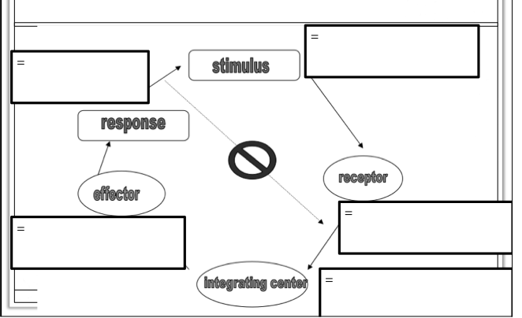
- Be able to do examples like those in the practice worksheet:
Put the problem that was the most challenging to you here:

Kidney Evolution
- Review the components of the paper
- Explain the structure and function of the nephron:
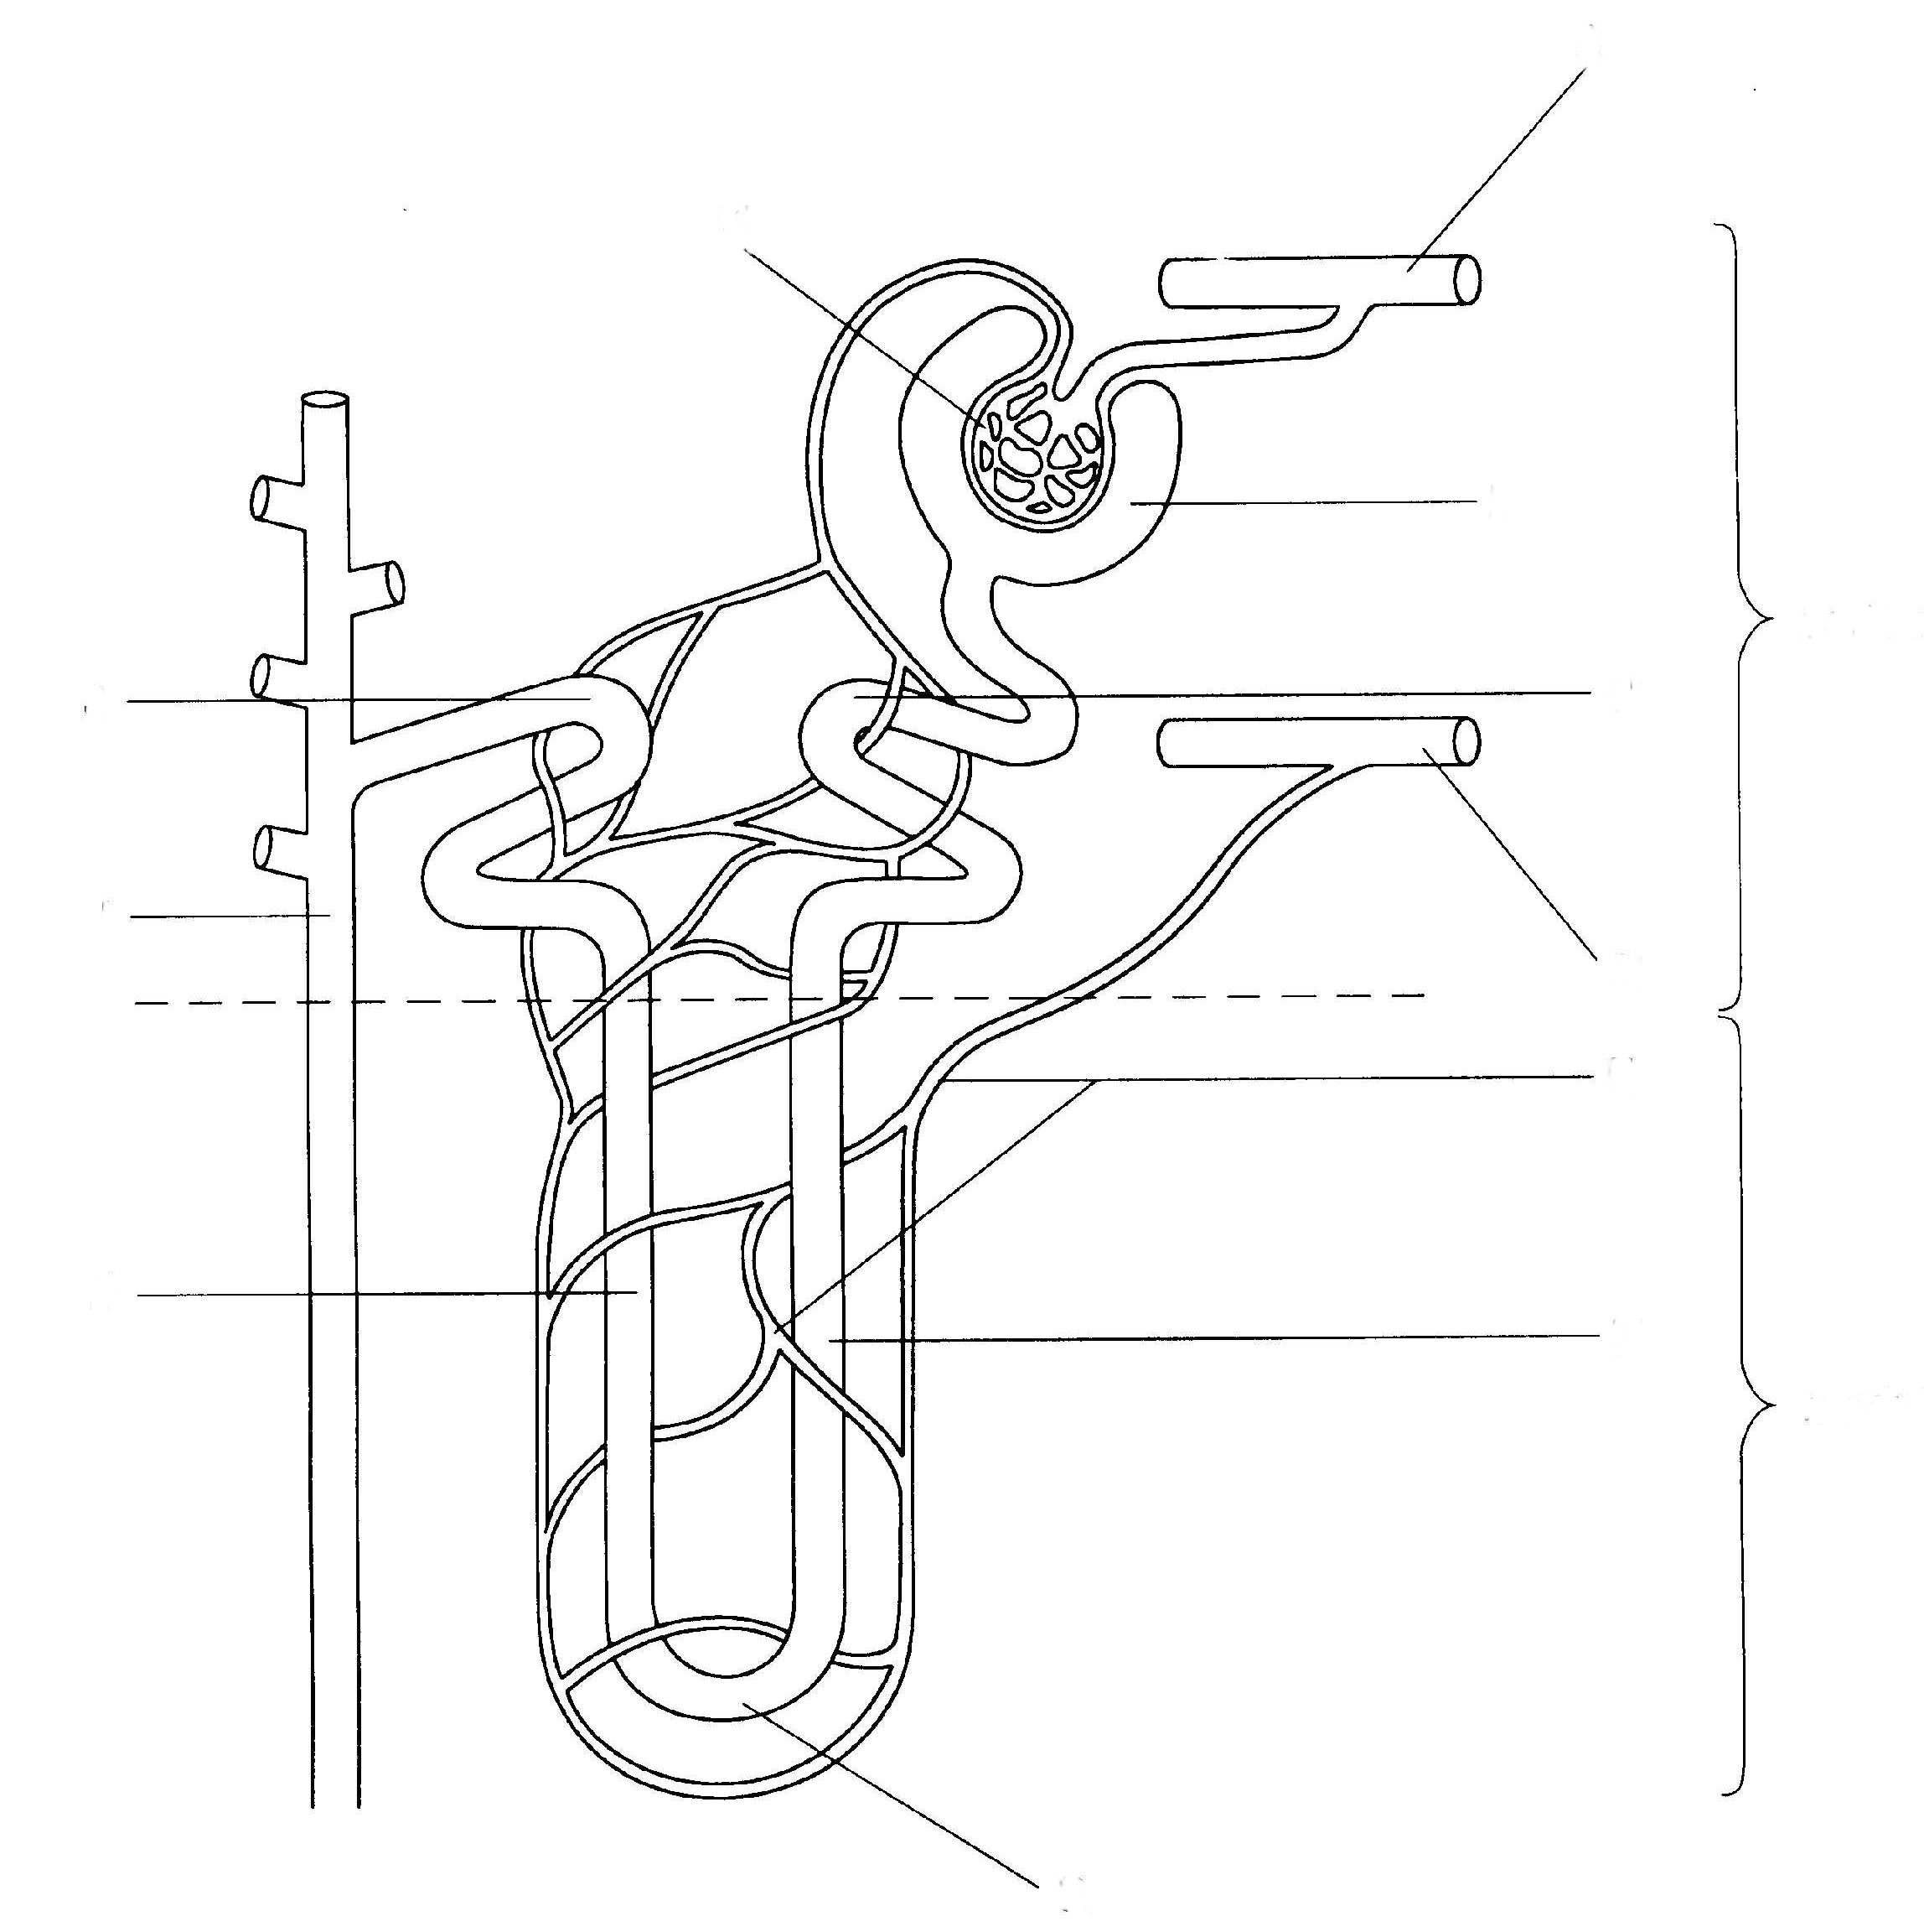
Renal Artery
Glomerulous
Bowman’s capsule
Descending loop of henle
Ascending loop of henle
Loop of henle (in general)
Collecting Duct

