Review for Cladistics
- Be able to construct and interpret a Phylogenetic Tree/cladogram

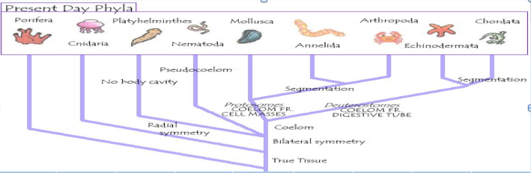
Interpret:
Are porifera more closely related to Cnidaria or Chordates? Why?

Are Annelids more closely related to arthropods or molluscs? Why?

What are the characteristics of all animals on this tree?

What are the characteristics ofplatyhelmenthies?

Where do you put the unique character of cnidaria, nematocysts, on the tree?

Review on Porifera and Cnidarians
- What are the 5 characteristics that all animals have?

- Which characteristic of sponges leads them to be called “porifera

- Describe the symmetry types of the porifera and cnidaria

- What are “spicules”, what are they made of, and what role(s) do they play in the porifera?

- Compare and contrast the following systems of the porifera and cnidaria:
  - Nervous:

- Digestive:

- Respiratory:

- Muscular (think about movment):

- Most porifera and cnidarians have a life cycle that includes both motile and sessile forms. Why might evolution favor this arrangement?

- Describe the structure and function of the nematocyst:

- Describe the structure and function of the Choanocyte/Collar Cell:

- Two forms seen in the cnidarian are the medusa and the polyp. Each has advantages. Discuss 3 of those advantages for each form.

- Why do Cnidarians swim so inefficiently?

